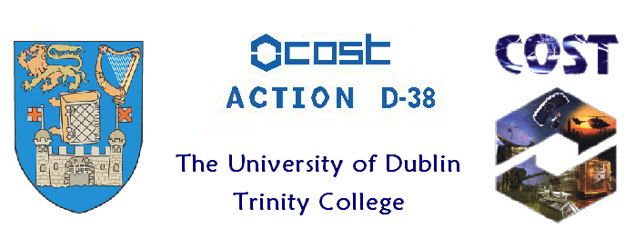

Joint meeting of the Working Groups 1 and 6 of the
COST D-38 Action
Dublin 19th of September 2008

Programme:

08.30-09.00 Registration and Coffee in the School of Chemistry
School of Chemistry Seminar Room

09.00-12.40 Scientific Programme: Lectures I and II
Chemistry Science Lecture Theatre

09.00-09.25 Prof. Stephen Faulkner
School of Chemistry, University of Manchester, UK
“Strategies for forming polymetallic complexes and bioconjugates for multimodal and targeted imaging"

09.25-09.50 Dr. Ilkka Hemmilä
PerkinElmer Life and Analytical Sciences, Turku, Finland
“Lanthanide chelates for imaging and monitoring of cellular signalling”

09.50-10.15 Dr Loic Charbonnière,
Laboratoire de Chimie Moléculaire, CNRS/ULP, Strasbourg, France
“Europium labels for one and two photons absorption applications”

10.15-10.40 Dr. Zoe Pikramenou,
School of Chemistry, University of Birmingham, UK
“DNA recognition and imaging at the nanoscale with lanthanide complexes”

10.40-11.00 Coffee and light refreshments
School of Chemistry Seminar Room

      - Soumaila Zebret
Department of Inorganic, Analytical and Applied Chemistry, University of Geneva, Switzerland
“Self-assembly of tetrahedral tetrametallic helicates: Structure and thermodynamics”

11.25-11.50 Dr. Simonetta Geninatti Department of Chemistry, University of Torino, Italy
“Nanoprobes as responsive MRI agents”

11.50-12.15 Dr. Célia S. Bonnet
School of Chemistry, Trinity College Dublin, Ireland
“Novel binuclear lanthanide luminescent peptide conjugates: Structural analysis in aqueous solution of potential metallo enzymatic mimics”

12.15-12.40 Dr Mark P. Lowe,
Department of Chemistry, University of Leicester, UK
"Click Chemistry with lanthanide complexes: a Word of Caution"

12.40-14.10 Poster Session and Light Lunch
Panozcon Institute

14.10-15.25 Scientific Programme: Lectures III
Chemistry Science Lecture Theatre

14.10-14.35 Dr. Goran Angelovski
Max Planck Institute for Biological Cybernetics, Tübingen, Germany
"Calcium-sensitive, Gd-based contrast agents for MRI"
Physiology of Cognitive Processes”

14.35-15.00 Prof. David Parker FRS
Department of Chemistry, Durham University, UK
“Responsive paramagnetic complexes for 19-F MRS/MRI“

      - Dr. Caroline D. B. Vandevyver
Ecole Polytechnique Fédérale de Lausanne (EPFL), Lausanne, Switzerland
“Lanthanide helicates: from cell imaging to lab-on-a-chip applications”

      - Prof. Donal F. O’Shea
School of Chemistry and Chemical Biology, University College Dublin, Ireland.
“Combining therapeutic treatment with fluorescence imaging.”

16.15-17.30 Management Meeting for All PI of the WG 1 and WG 6
School of Chemistry Seminar Room (Agenda to follow)

17.30-19.00 Beer and Wine Reception
School of Chemistry Seminar Room

