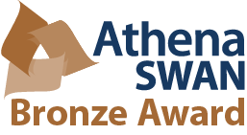
Chemistry Athena Swan Action Committee/Self-Assessment Team:
Membership:
Aidan McDonald <aidan.mcdonald@tcd.ie>; Eileen Drew <EDREW@tcd.ie>; Eva-Maria Dürr <DURRE@tcd.ie>; Isabel Rozas <ROZASI@tcd.ie>; Michael Lyons <MELYONS@tcd.ie>; P. Noelle Scully <PNSCULLY@tcd.ie>; Peter Brien <Peter.Brien@tcd.ie>; Sinead Boyce <SBOYCE@tcd.ie>; Susan Cantwell <SCANTWE@tcd.ie>; Graeme Watson <watsong@tcd.ie>; Parvaneh Mokaria<mokariap@tcd.ie>; Maria Daniela Angione
<angionem@tcd.ie>; Sylvia Draper <SMDRAPER@tcd.ie> (Chair)

ASSAT 7: Meeting 11:00 am Wednesday Aug. 15th 2018, New Seminar Room

Agenda:
- Agree Minutes of ASSAT(6)
- Matters Arising

- Reports from Members [on individual actions]

- AS proposal writing (Dos and Don’ts) - Tony McMahon

- Timeline for meeting(s) after first full application draft (deadline Sept 1st)

- Mechanism for data sharing/data presentation between section writers

