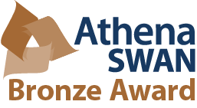
Chemistry Athena Swan Action Committee/Self-Assessment Team:
Membership:
Aidan McDonald <aidan.mcdonald@tcd.ie>; Eileen Drew <EDREW@tcd.ie>; Eva-Maria Dürr <DURRE@tcd.ie>; Isabel Rozas <ROZASI@tcd.ie>; Michael Lyons <MELYONS@tcd.ie>; P. Noelle Scully <PNSCULLY@tcd.ie>; Peter Brien <Peter.Brien@tcd.ie>; Sinead Boyce <SBOYCE@tcd.ie>; Susan Cantwell <SCANTWE@tcd.ie>; Graeme Watson <watsong@tcd.ie>; Parvaneh Mokaria<mokariap@tcd.ie>; Sylvia Draper <SMDRAPER@tcd.ie> (Chair)
Meeting 3:00 pm Tuesday April 17th 2018, New Seminar Room

Agenda:
- Agree Minutes of ASSAT(3)
- Matters Arising

- Review of feedback on Physics and Natural Science AS applications:

- Reports from Members on individual actions:

Next meeting date 12th June 3:00 pm

