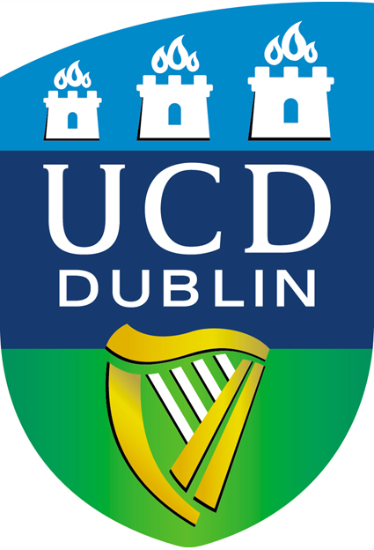 | 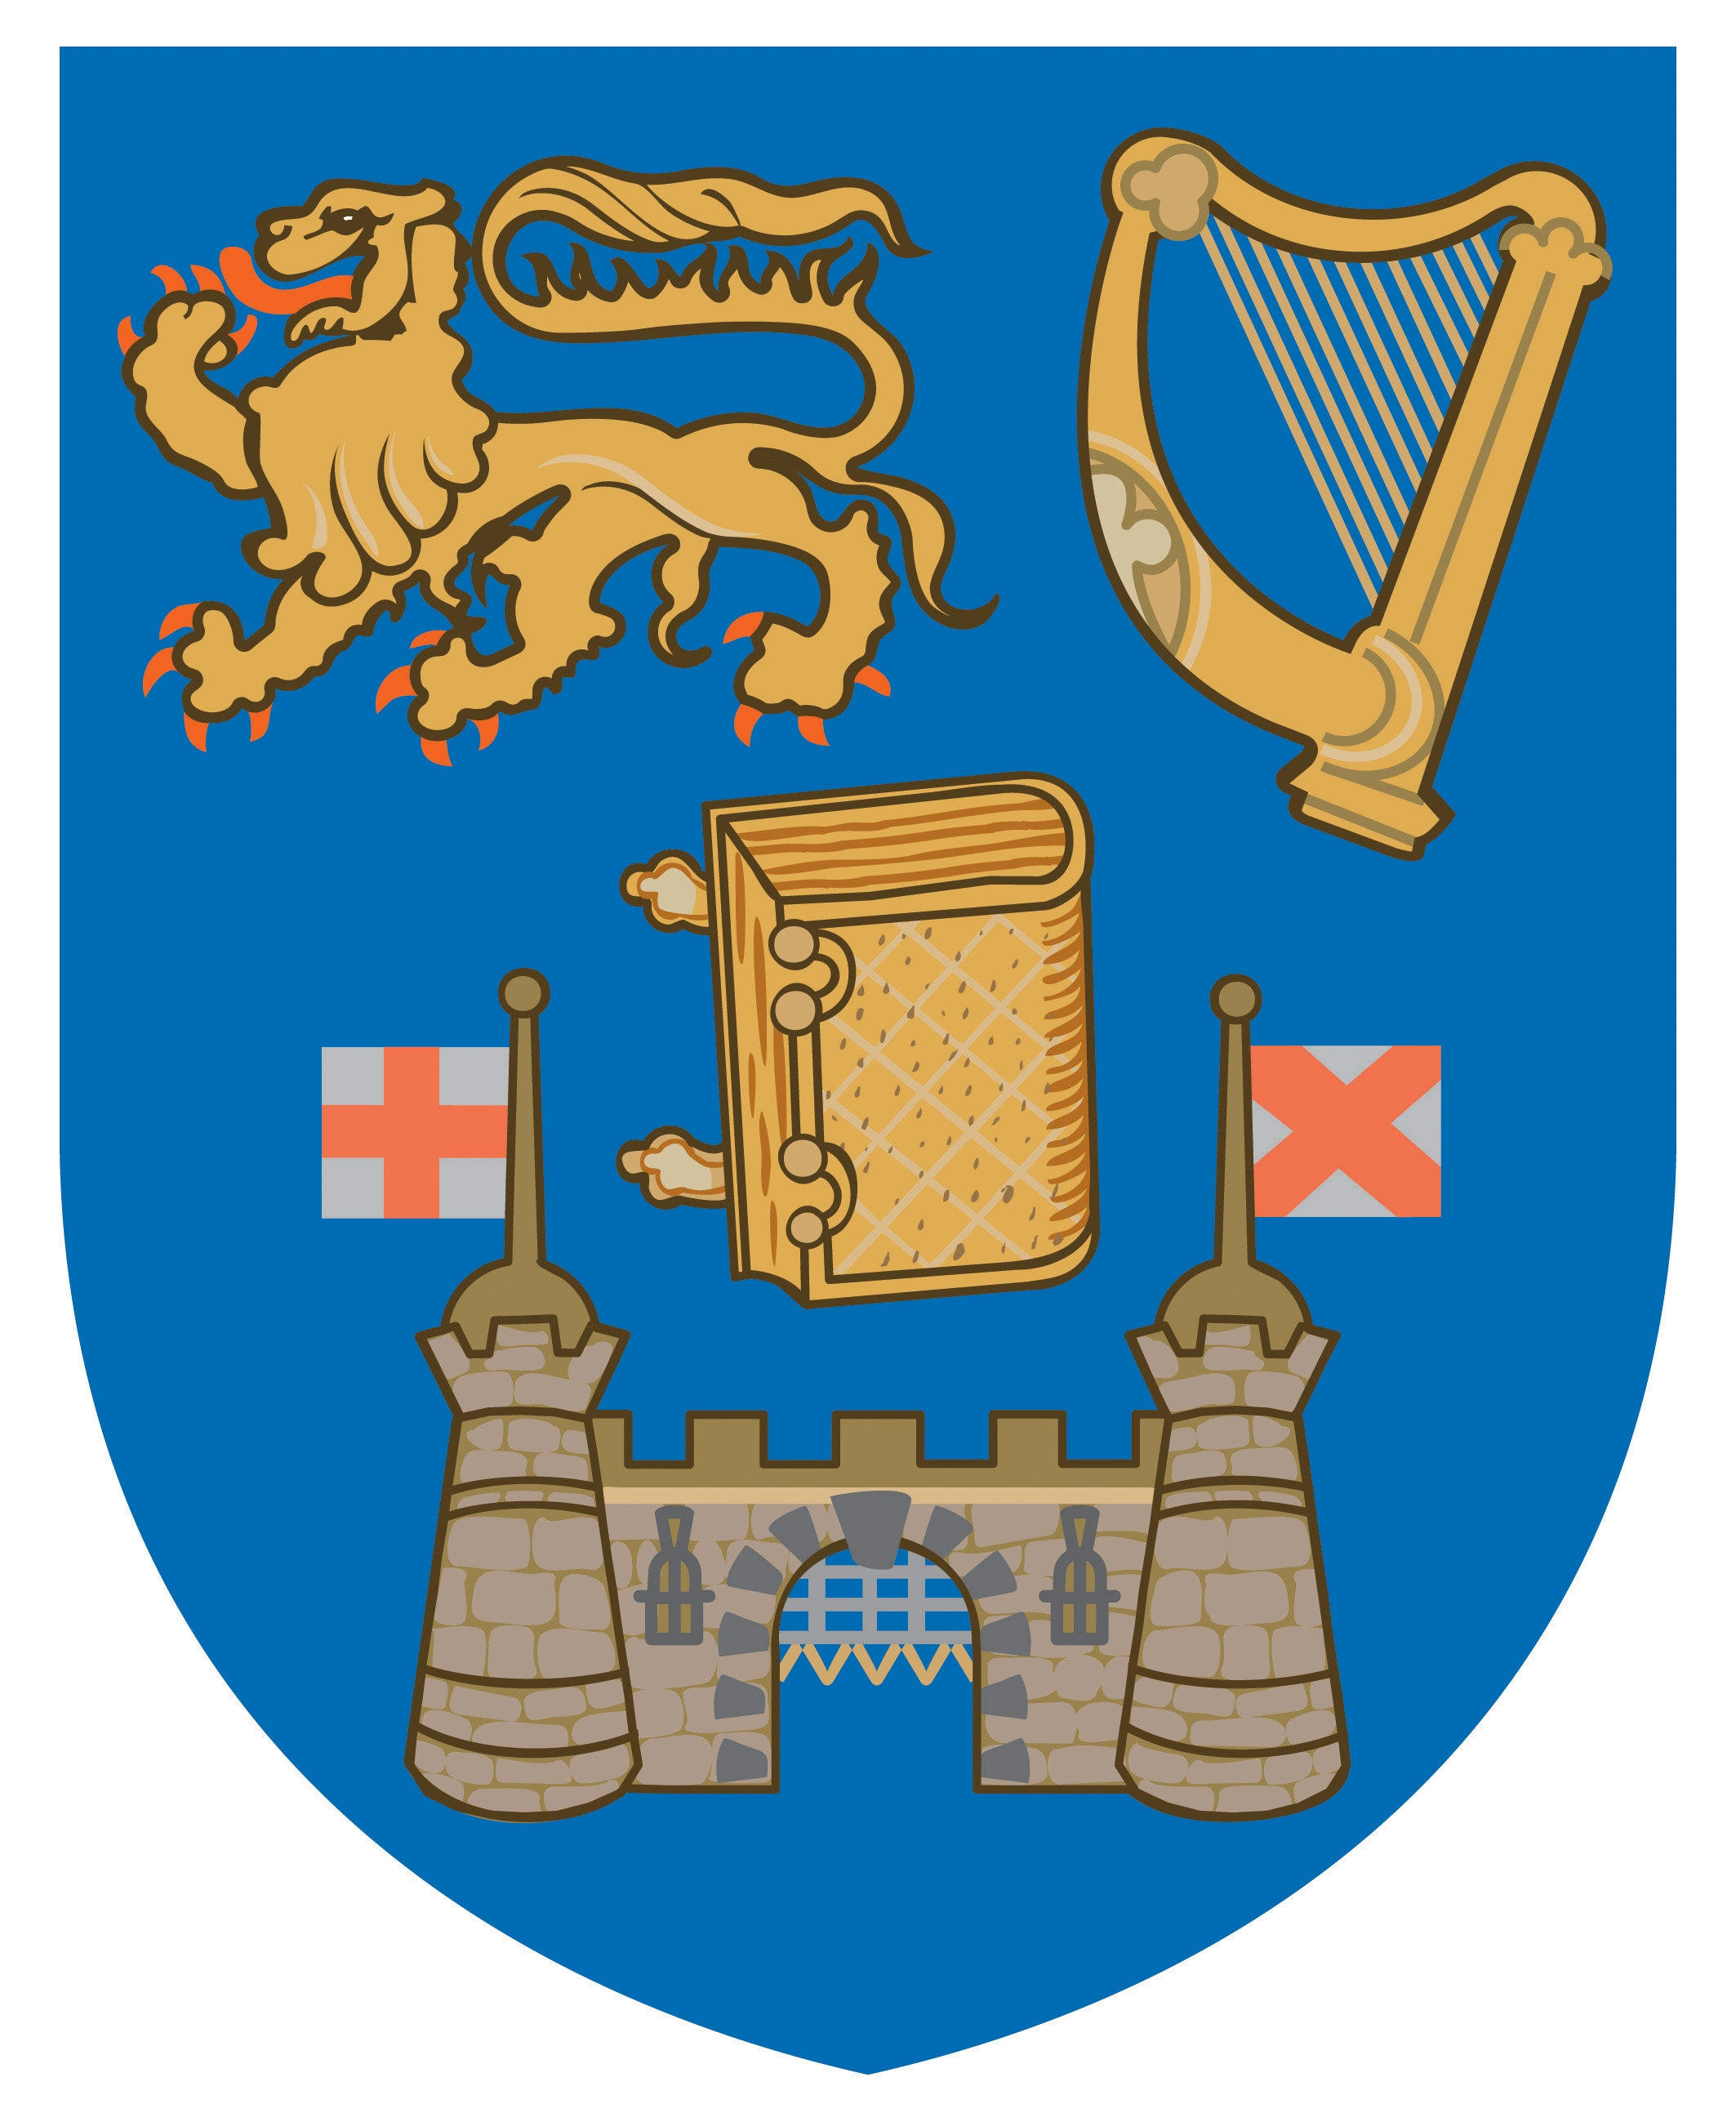  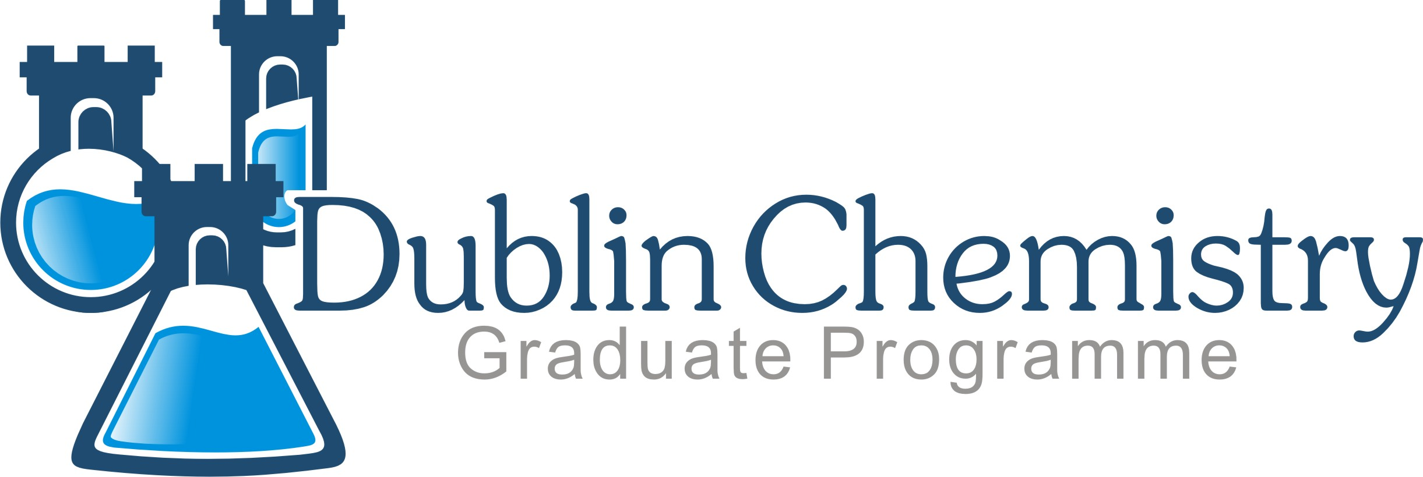

Dublin Chemistry Joint PhD – Module Enrolment Registration Form
2015 / 2016

Students enrolled to the joint Dublin Chemistry PhD programme at UCD/TCD may avail of taught modules from those offered from within Dublin Chemistry. Students should seek the advice of their principal supervisor and/or the Dublin Chemistry administrator for further details of relevant modules. To enrol for modules, research graduate students should complete the relevant details below, obtain the signature of their principal supervisor, and submit the form to the UCD School of Chemistry and Chemical Biology office within 2 weeks of the start of the module.
It is important to note that no student can be retrospectively registered to a module so please ensure that you complete this form asap

Personal Information
Name :
UCD Student No :
PhD start date (Month and Year):
Date of Birth:
School:
Email Address:

Programme Information
Programme Code (For PhD DRSCI001 / MSc MREMP007) :
Programme Title (ie: PhD/MSc) :

Please note that, once registered for a module, if for any reason you do not complete it or do not officially withdraw from the module within 6 weeks, the NG grade received will be entered onto your university record and will appear on your transcript. To withdraw from a module or change your status to AUDIT (students attend classes but do not participate in assignments or assessment and NO credits are awarded), please contact the Dublin Chemistry administrator within 6 weeks of the commencement of the module. NO RETROSPECTIVE CHANGES CAN BE MADE

Modules
Module Code | CRN (office use only) | Module Title | Module Co-ordinator | ECTS Credits | Audit Only (Please tick)

SIGNATURES:

Principal supervisor signature: |  | Print Name of supervisor:
Name of Module Coordinator* |  | Approval of Module Coordinator
Student signature
Processed by : |  |  |  | Date:

