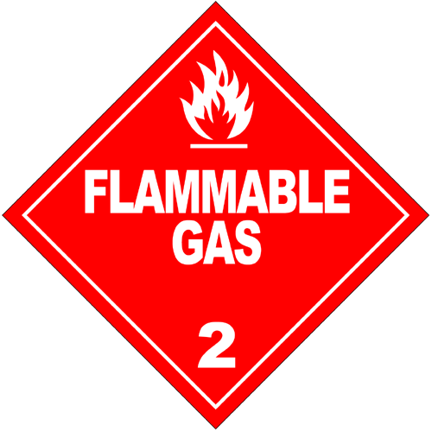
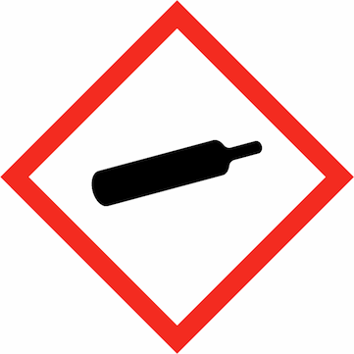
CAUTION
COMPRESSED GAS CYLINDERS IN USE!

Date: |  | Room/Lab Number: |  | IN AN EMERGENCY  CONTACT;
Location in room/lab:
Gas type: | Carbon Monoxide | Cylinder size:
Symbols: | 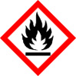  GHS02 | 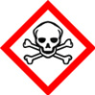  GHS06 | 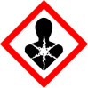  GHS08 | SUPERVISOR
 |  |  |  | TEL
 |  |  |  | PERSON 1
 |  |  |  | TEL
 |  |  |  | PERSON 2
Signal Word: | DANGER |  |  | TEL
Hazard Statements: | H220, H280, H331, H360D, H372 | Precautionary Statements: | P201, P210, P261, P311, P410, P403 | Further Notes:
Used for:
Student name: |  | Supervisor name:
Student Signature: |  | Supervisor Signature:
SCHOOL OF CHEMISTRY

