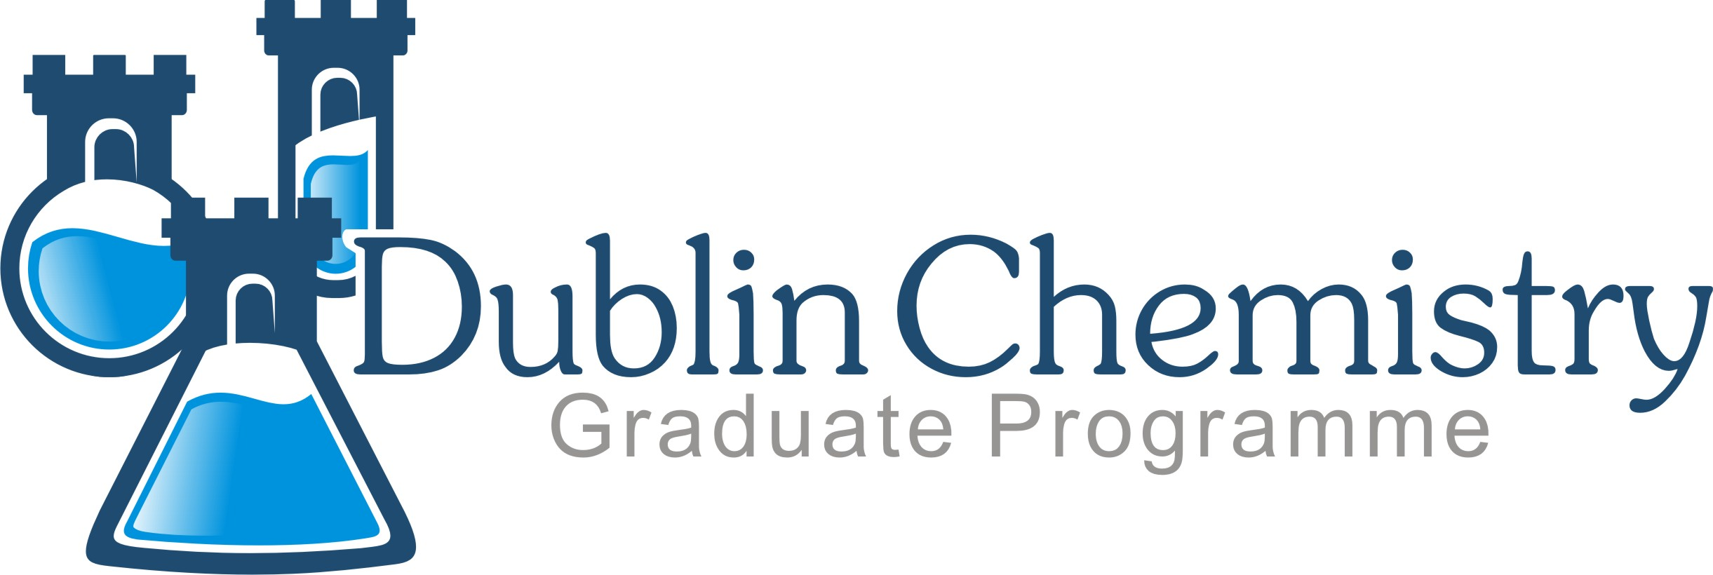

Guidelines for Seminar Series

CHEM40160 - Year 1 CHEM40280 - Year 2 CHEM40520 - Year 3

Integrated Seminar Series
The ability to concisely describe a topic in the form of an abstract is an essential communication skill in science. This module aims to develop this skill through the practice of summarizing seminars attended during the academic year. Students are required to attend a minimum of 12 seminars throughout the year and record these in a seminar list. A summary should be a short synopsis of the talk (1/2 page, ~ 250 words). Students may finish the report with their own personal ‘critical’ opinion of the seminar. A template and examples are given below.

Under no circumstances should text or images be cut and pasted into the report.
Any plagiarism will result in failure of the module.

To avoid a heavy workload at the end of each semester students are encouraged to write their synopses throughout the year.

Submission deadlines:
Semester 1: 6 seminar summaries by Friday 9 December 2016
Semester 2: 6 seminar summaries should be combined with those from Semester 1 and submitted as a SINGLE pdf of 12 summaries by Friday 19 May 2017

All submissions should be provided in a single PDF document with the title comprising the appropriate module code, your first and last name and the submission date, e.g. CHEM41060_Maria_Copley_20161111 and should be e-mailed to Maria Copley and Prof. Dónall Mac Dónaill (copleym@tcd.ie and Donall.macdonaill@tcd.ie)

Eligible seminars include:
School of Chemistry (TCD) and School of Chemistry and Chemical Biology (UCD) Seminar series
Seminars in other Schools of Chemistry in Ireland
Seminars in relevant disciplines (Biochemistry, Physics, Engineering)
Seminars in institutes (Conway, CRANN, TBSI, IMM)

Seminars should be of 50-minutes’ duration.

Note: A maximum of two seminars are allowed from a one-day meeting held in Ireland and, again, only if they are of standard 50-minute duration. Examples include annual CSCB meeting, RSC full/half-day meetings

Seminars from international conferences are NOT to be included.

YOUR NAME AND UCD STUDENT NUMBER

Seminar Summary

Seminar

Date | Seminar Title | Speaker
½ page Seminar summary

A.N. Other (12345678)

Seminar Summary

Seminar

Date | Seminar Title | Speaker
09/11/16 | Transparent Metal Oxides, Metals You Can See Through | Russell Egdell
½ page Seminar summary
This seminar largely covered an examination of the energy levels of a variety of doped metal oxides that are noted to be transparent in the visible region while reflective in the IR region. As a result they would be useful for a variety of applications. The applications investigated concentrated on the electronics industry, such as novel light emitters as well as transistors. The material presented contained a strong physics component but as far as I could determine it involved the use of surface sensing techniques such as PES (photon electron spectroscopy) and XR emission spectroscopy, both of which were used to investigate the magnitude of the band gap of the semiconductors. This data was utilised along with computational work to try and answer problems concerned with the exact magnitude of the band gap of Indium Tin Oxide (ITO) The solution would appear to rest on consideration of the transitions from the valence band of the material up to the conduction band.
These kinds of materials where then shown to have promise for the production of novel organic light emitting diodes (OLEDs) as well as transistors.

A.N. Other (23456789)

Seminar

Date | Seminar Title | Speaker
16/11/16 | Cheme-enzymatic approach to the synthesis of small chiral molecules | Francesca Paradisi, CSCB, UCD
Enzymes are environmentally friendly and have high enantioselectivity. However they have limited substrate specificity, are unstable and are cofactor-dependent so are difficult to work with. Phenylalanine dehyrogenase (Bacillus sphaericus) displays these characteristics. One way to increase the substrate specificity is to introduce residues on the aromatic ring

Phenylalanine (OH-tyrosine)

Site directed mutagenesis can be carried out on Asn¹⁴⁵, introducing Ala, Val, Leu or Ile to remove the possibility of H-bonding. From these mutated enzymes new substrate specificities are achieved. The synthesis of non-natural amino acids is expensive as the cofactor needs to be recycled after synthesis and the starting material may not be widely available. Substrate and product solubility along with difficulty in purifying the product can also be issues. The lecturer detailed synthesis of 2-oxo-acids e.g. azalactone. She found that she got a better yield without using a microwave as this may cause disintegration. Similar results were observed for aliphatic aldehydes. Using a hydantoin strategy improved yields. Enzymatic reactions with non-natural substrates can be followed using chiral HPLC, with yields of 50-86% and the purification does not affect enantiopurity. The substitution of an aromatic ring affects the solubility and thus may require the addition of organic solvents (co-solvents).

Novel alcohol dehydrogenases are being isolated from halophilic organisms as a source of biocatalysts. These organisms have a high tolerance to salt (4M). They thus have an advantage of being tolerant to organic solvents and higher temperatures. However they are produced as insoluble proteins, have purification issues and some refolding of the protein can occur.

